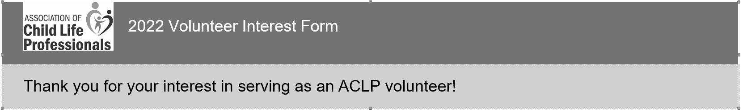
Please review the 2022 Volunteer Interest Guide before beginning your application. Each group has specific questions to help identify the knowledge and skills needed for their work. These questions are listed by committee in the 2022 Volunteer Interest Guide. We highly recommend reviewing the guide and drafting your responses prior to starting the application.
The application must be completed in one sitting - you cannot save your work and finish later.

*1. First Name
*2. Last Name
3. Credentials
*4. Education Level
__ High school diploma/GED __Bachelor (4-year) degree
__Some college __ Master’s degree
__Associate (2-year) degree __ Doctoral degree
5. Title
6. Organization/Employer
7. Program Size
*8. City
*9. State/Province
*10. Time Zone
*11. Preferred email address
*12. Race/Ethnicity
__White/Caucasian __Black/African American
__South Asian __East Asian
__Hispanic/Lantix __Middle Eastern/North African
__West Indian/Caribbean __American Indian/Alaskan Native/Pacific Islander/Other
Indigenous People
__ Two or more races __ Other
__Prefer not to say
*13. Gender
__Agender __Androgyne __Demigender
__Genderqueer or gender-fluid __Man __Question or unsure
__Trans man __Trans woman __Woman
__Other gender category/identify
__Prefer not to say
*14. Age
__ 24 and under __25-29 __30-39
__40-49 __50-59 __60+
*15. Employment Status
__ Full time in child life (includes community-based roles in which one heavily uses child life knowledge and skills)
___ Part time part time in child life (includes community-based roles in which one heavily uses child life knowledge and skills)
___ PRN in child life
___ Employed outside of child life, currently seeking child life employment
___ Employed outside of child life, not currently seeking child life employment
___Not employed
___ Retired
___Other (please specify)
*16. If you work in a hospital, please check all that apply:

___ Free-standing children’s hospital ___ Chi8ldren’s hospital within an adult hospital

___Adult hospital with pediatric services ___Rural hospital

___Urban hospital ___Other (please specify)

*17. Please indicate which of the following, if any, apply to you

___ Internship coordinator (responsible for overall administration of the internship program, not just rotation supervision)

____ Practicum coordinator (responsible for overall administration of the practicum program, not just rotation supervision)

____ACLP Diversity scholarship recipient

____Undergraduate Student

____ Graduate Student

____Part-time/don-degree seeking student

___N/A

18. How many years of paid child life experience do you have?

__0-5 ___6-10 ___11-15

__16-25 ___25+ years

*19. Employment Category (check all that apply to you)

__ CCLS in hospital setting, inpatient ___ Academic instructor (part time or adjunct)

___CCLS in hospital setting, outpatient ___CCLS in community-based setting (includes private practice)

___CCLS program leader (no clinical load) ___ Child life assistant in hospital setting

___CCLS program leader (with clinical load) ___Student

___ Other (please specify)

*20. Student Status (check all that apply to you)

___Undergraduate ___Graduate

___Non-degree seeking ___ N/A ___ Other (please specify)
About You

ACLP's volunteer selection is a blind process. Prospective volunteers will be evaluated and selected for committees based on their answers to the questions below and to any committee-specific questions. Please be sure to complete all free answer questions or your application will be considered incomplete.

*21. Please list any committee or volunteer experience in your workplace, community, or regional child life group. (limit 1000 characters)

*22. What attributes do you have that would make you a good committee member? (limit 1500 characters)

*23. What unique skills will you bring to an ACLP committee? (limit 1500 characters)

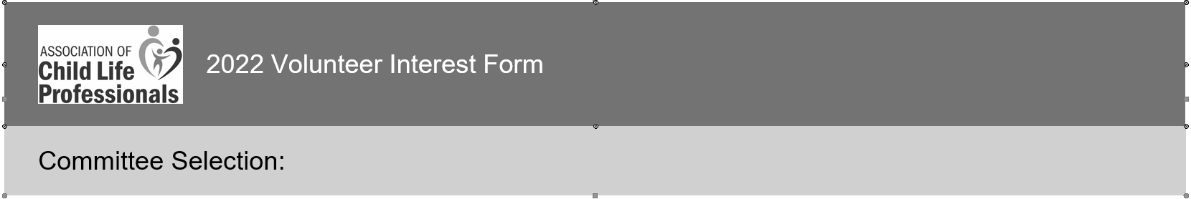

Please review the committee descriptions in the 2022 Volunteer Interest Guide before choosing committees of interest.
*24. Please select only three committees and add 1, 2, 3 in order of preference
___Archives Committee ___Education and Training Committee
___Awards Committee ___Mentor Program
___Benchmarking Committee ___Publication Committee
___Bulletin Committee ___Professional Resources Committee
___CCLS Item Writers Committee ___Volunteer Recruitment and Engagement Committee
___Community Based Practice Committee ___Web and Online Committee (WOC)
___Conference Planning Abstract Reviewers ___I am only interested in Membership Advisory Group

Archives Committee

Please answer the following questions to help Archives Committee leaders better understand your interest in this group and relevant skills and experiences.
*25. Why is the history of our profession important to you?

*26. What interests you about joining Archives Committee?

Awards Committee

Please answer the following questions to help Awards Committee leaders better understand your interest in this group and relevant skills and experiences.
*27. Does the volunteer applicant have skills in reviewing and/or creation of documents?
___Yes
___No
If yes, please describe.

*28. Does the volunteer applicant have effective skills in time management, adherence to deadlines, and collaboration?
___Yes
___No
If yes, please describe.

*29. Does the volunteer applicant have knowledge of the awards and scholarships offered by ACLP, with an interest and understanding in the research and publication process?
___Yes
___No
If yes, please describe

Benchmarking Committee

Please answer the following questions to help Benchmarking Committee leaders better understand your interest in this group and relevant skills and experiences.
*30. What is your comfort level in using the data center?
___Entering Data ___Pulling Reports ___Interpreting Data
___Applying Data To Own Setting ___Other (please specify)

Bulletin Committee
Please answer the following questions to help Bulletin Committee leaders better understand your interest in this group and relevant skills and experiences.
*31. Describe your experience in professional writing and list any publications to which you have contributed.

*32. If you have ever participated in editing with written work of others, please describe your experiences

CLCC Item Writers Committee
Please answer the following questions to help CLCC Item Writers Committee leaders better understand your interest in this group and relevant skills and experiences.
*33. Is there anything that may prevent you from completing your commitment to this committee? (i.e. PTO, job change)
___Yes
___No
If Yes, please explain:

*34. Are you able to commit to weekly virtual meetings to discuss your items?
___Yes
___No

*35. Share a time that you received feedback and implemented it.

Community Based Practice Committee
Please answer the following questions to help Community Based Practice Committee leaders better understand your interest in this group and relevant skills and experiences.
*36. Do you currently practice in a community based setting or have you ever worked in a community based setting in the past?
___Yes
___No
If so, for how long and in what type of setting/role?

*37. Have you had previous experience mentoring other CCLSs in a community based/non-traditional role?
___Yes
___No
If yes, please describe.

*38. What type of volunteer experience have you had either on an ACLP Committee or outside of your work as a CCLS?

Conference Planning Abstract Reviewers
Please answer the following questions to help Conference Planning Abstract Reviewers leaders better understand your interest in this group and relevant skills and experiences.
*39. Are you available to review in July – September?
___Yes
___No

Education and Training Committee
Please answer the following questions to help Education and Training Committee leaders better understand your interest in this group and relevant skills and experiences.
*40. Elaborate on your experience with presentations

*41. Elaborate on your experience with exam writing (or just professional writing experience in general)

*42. Elaborate on your experience with clinical supervision, practicum/internship coordinator role, and/or academic positions

Mentor Program
Please answer the following questions to help Mentor Program leaders better understand your interest in this group and relevant skills and experiences.
*43. What is your experience with mentoring, formal and informal?

*44. When you are working on a project with a deadline, how do you ensure that you are able to stay on task to meet the deadline?

*45. What does taking initiative look like to you?

Professional Resources Committee
Please answer the following questions to help Professional Resources Committee leaders better understand your interest in this group and relevant skills and experiences.
*46. Do you have any experience critiquing analyzing professional resources?
___Yes
___No
If Yes, please describe.

*47. Do you have any interest or experience writing articles, blogs, book reviews, etc.?
___Yes
___No
Other (please specify)

*48. How many hours can you contribute on a monthly/quarterly basis?

Publications Committee
Please answer the following questions to help Publications Committee leaders better understand your interest in this group and relevant skills and experiences.
*49. What experience do you have with writing and publishing? (Can be your own work, copyediting others work, serving on other review boards, etc)

*50. Which ACLP publication would you identify as one that needs revision? Why?

Volunteer Recruitment and Engagement Committee (VRE)
Please answer the following questions to help Volunteer Recruitment and Engagement Committee leaders better understand your interest in this group and relevant skills and experiences.
*51. What is your level of comfort working with people virtually?

*52. Please tell us about a time you thought outside the box.

Web and Online Committee (WOC)
Please answer the following questions to help Web and Online Committee leaders better understand your interest in this group and relevant skills and experiences.
*53. What experience do you have in managing social media accounts and creating content?

*54. Are you familiar with Slack?
___Yes
___No

*55. If you were selected to be a volunteer for WOC, what do you hope to gain from the experience?

Other ACLP Working Groups
ACLP members can serve simultaneously on a committee/task force and on the Membership Advisory Group.
Membership Advisory Group (MAG)
The Membership Advisory Group (MAG) shares their feedback and expertise and operates as a focus group with the ACLP Staff and Board of Directors. The MAG will be asked for specific feedback on new member programs and services, communication initiatives, and other requests as needed. The MAG will consist of members representing different segments of the overall ACLP membership. Participating in the Membership Advisory Group does not qualify for PDUs.
*56. I would like to be considered for the Membership Advisory Group.
___Yes
___No

